JAC Products, Inc.

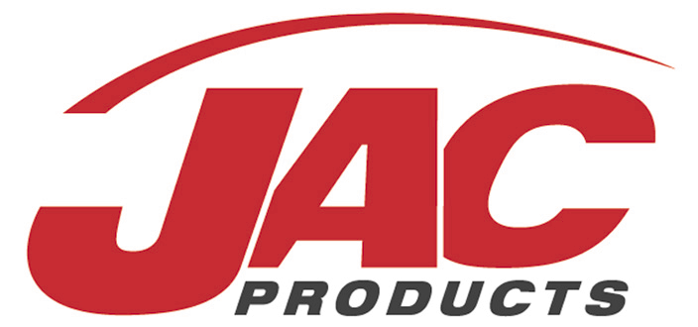

Corporate Materials
Corporate Offices
225 South Industrial Drive
Saline, Michigan 48176
(734) 944-8844

Supplier Packaging Guidelines

Table of Contents

- Purpose…………………………………………………………………………………………………….3
- Supplier Responsible……………………………………………………………………………..….3
- Packaging Guidelines……………………………………………………………………………..….3
- Returnable Specs……………………………………………………………………………………….4
- Expendable Specs………………………………………………………………………………………6
- Deviated (Backup) Packaging Guidelines……………………………….…………………..6
- Backup Specs……………………………………………………………………………………….…….6
- Testing………………………………………………………………………………………………………7

- Purpose

  - The purpose of this document is to standardize the packaging and labeling that JAC Products suppliers use. The goal is to ensure that high quality parts are received and delivered for JAC Products.

- Supplier Responsibilities

  - Purchase part suppliers are held responsible for quoting, designing, acquiring, and necessary maintenance of desired packaging throughout the life of the program. Additionally, all returnable and expendable package quoting must be incorporated as a separate line item and included in the piece price. Amortize all packaging costs including tooling, prototypes, testing, etc. An itemized breakdown of the packaging will need to be submitted to the buyer and packaging engineer.
      - Suppliers are required to have a PDS (Packaging Data Sheet) signed and approved by a JAC packaging engineer before procurement and PPAP
      - Suppliers to supply fleet size calculation based on MPW (maximum production weekly) and maintain sufficient returnable or expendable containers to support all production
      - All fleet sizes are to be calculated using projected scrap rates
      - Suppliers must submit post approval pricing of expendable back-up packaging prior to the supplier PPAP
      - Suppliers are accountable for maintaining part quality in any returnable or expendable packaging
      - Standard system days for returnables at JAC is 4 days. For any deviations, JAC packaging engineer will contact supplier

  - Parts manufactured at JAC and sent to an outside processor will have JAC owned returnable packaging. However, it is the responsibility of the supplier to ship a quality part, do not ship in any packaging that jeopardizes the part quality due to damaged packaging. Examples include dunnage that is ripped, contains excessive dirt, or foreign objects unable to wash off. If any packaging has questionable damage, please provide pictures along with a detailed description to the packaging engineer before continued use.
      - Confirm with JAC ahead of time whether the packaging is used within the suppliers WIP, this will determine the system days needed
      - JAC will determine if 1 or 2 loop sizes would be needed. 2 loop sizes are needed if the WIP packaging can get dirty and therefore jeopardize the quality of the finished good part

- Packaging Guidelines

  - When possible hold parts on D surface and protect the A,B,C surface
      - If needed to be held on A, B or C surface then class A friendly material is required
        - For class A friendly material examples refer to section 4.5

  - Protect the end of the parts (keep in mind the possible damage from loading/unloading rails)

  - Look at cost saving material/designs without risking the quality of the part

- Returnable Specs

  - Handheld Totes
      - Approved suppliers are Orbis, Monoflo, Buckhorn and Schaefer
        - The exterior dimensions below are the preferred standard sizes
L | W | H
12” | 15” | 7”
24” | 15” | 7”
24” | 15” | 14”

        - Cut and weld totes may be an option if optimum density is not reached with standard sizes or if part dimension requires it
      - Maximum gross weight of 35 lbs per container
      - JAC packaging engineers are to provide target density (hourly rate at which the part is manufactured will be a factor)

  - Knockdowns
      - Approved suppliers are Orbis, Monoflo and Buckhorn
        - Standard size containers are 48” x 45/56/64/70/78” x 34” (LXWXH)
      - Containers need to be heavy duty and must not exceed weight capacity (refer to manufacture container capacity)
      - Parts that need a container longer than 78” will need to use unique packaging such as a steel rack or EPP foam (no cut and weld knockdowns)

  - Unique Returnable Packaging
      - Horizontal Steel Racks
        - Standard sizes (inside dimensions length-TBD width-28” height- 18”)
          - 62.5” x 32” x 25.5”
          - 78” x 32” x 25.5”
          - 96” x 32” x 25.5”
        - Structure
          - WIP racks 1.5” tubing
          - Finished Good racks 2” tubing
          - Confirm with plant that structure does not interfere with process or footprint. (Signed PDS sheet)
          - All walk in racks must contain expanded metal
          - Storage area on racks is required when using loose dunnage
      - Fork Pockets (add with Horizontal racks)
        - 3x8 tubing required for racks with increased weight/length/width (>96” length and >48” width)
      - Vertical steel racks
        - Use for molded rails/pads
          - If part design has a spot included where it can hang
        - 48” x 45” standard footprint (height depends on length of part)
        - Cover rack with class A friendly spray or tape if there are any concern areas where the part can be damaged when loading and unloading part
      - Add “pinch point” sticker where needed
      - EPP (Expanded Polypropylene)
        - Full trays on a pallet/lid or end blocks in a steel rack
        - Determine if tooling from existing/old program can be used to save cost
        - Include drain holes if the design does not allow water to escape if stored outside

  - Stenciling/Placards/Hot-stamps
      - Each tote must contain the following information on length panels (hot stamp or label) and 2 Kennedy labels on the width panels
        - Property of (container owner)
        - Return to
          - Vendor Name
          - Vendor City
          - Vendor State
        - Program Code / Part Description
        - JAC Part Number (Provided by Packaging Engineer once packaging is approved)
        - JAC container #
      - Vertical Racks
        - Property of (container owner) on the bottom 2 or 3 kick plates
        - Program code/ part description running vertically on all 4 corner posts (2 outside position) 8 total locations
        - Container number vertically on adjacent corners
      - Horizontal Racks
        - Property of (container owner) along 4 top cross bars
        - Program code/ part description along 4 bottom cross bars
        - Container number vertically on adjacent corners

  - Internal Dunnage
      - Used only where part design/part finish requires (if not bulk pack)
        - Hand held totes
          - If the part is delicate or has surface appearance classifications, an acceptable divider is poly spun, spuntex, brushed nylon or equivalent material. Packaging must provide protection to the end of parts with a pad on the bottom of tote.
          - If the part needs dividers due to weight/shape with no surface appearance classifications p-corr is an adequate material to use (4 or 5 mm). Note, lamination or base pads are not mandatory, but may need to be considered
        - Knockdowns/Steel Racks
          - If the part is delicate or has surface appearance classifications, examples of materials to be used included EPP foam blocks or crosslink foam (density will fluctuate), hold from D surface if possible and protect the ends of the parts
          - Example of protecting the end of part
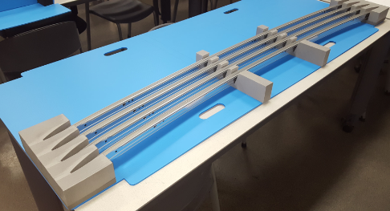
          - Layer pads (full) are preferred to help with loading and unloading
          - C-channels are needed for finger foam that is not glued on to layer pads, confirm that length of channel and foam are compatible to prevent foam popping out
          - Loose finger foam must be crosslink and needs stiffener (example PVC)
          - Density determined by weight and structure of the part
        - Any material used other than the examples above must be discussed and approved with the JAC packaging engineers during design phase (PDS Sheet)
- Expendable Specs

  - The standard expendable sizes are including, but not limited to the below
      - Standard sizes increase the efficiency of cubing the truck and therefore reducing the carbon footprint and waste
L | W | H
12” | 15” | 7”
24” | 15” | 7”
24” | 15” | 14”
48” | 45/56/64/70/78” | <=48”

  - If part is delicate or has surface appearance classification then dunnage should be used to protect the part from getting damaged
      - Corrugated dividers should be used to prevent part to part contact if necessary
      - If corrugate is too abrasive on the part a poly/cloth bag or corrugate coating should be used

  - To help the stacking strength pallet loads should be stretch wrapped (corner boards if needed) or banded to the pallet

  - There is to be no box over hang on any pallets with minimum under hang

  - Boxes with a bigger footprint than 48” x 45” in either direction need to be double wall with drop down panels
      - This is general and may change depending on the specific application

- Deviated (Backup) Packaging Guidelines

  - Suppliers are to have backup packaging designed and approved (via PDS) by PPAP

  - Suppliers are expected to have an adequate amount of backup to cover shipments should returnable not be available
      - If JAC pulls above quoted volume or does not return totes in timely manner then suppliers must receive written authorization from the receiving location (material planner) before shipping in deviated packaging (JAC responsible for reimbursement)
  - Alternate pricing for deviated packaging must be agreed upon with JAC Purchasing

  - Suppliers are responsible for maintaining part quality in any backup packaging

- Backup Specs

  - Backup packaging must be the same footprint and have the same part density as the returnable packaging. This will ensure that standard pack quantities are followed and the rack/container locations used for storage will still work.

  - Reference section 5. Expendable Spec for more detail with design.

- Testing

  - Testing is used to evaluate the integrity of both expendable and returnable packaging. Please confirm that the packaging will protect the part throughout the entire process, including transportation. The testing that the packaging will go through should be kept in mind and communicated during the design process.

  - Expendable
      - Shipped to end user/customer by FEDEX
        - Requires ISTA testing which is a series of drop impact, compression, and vibration tests. Place kit box into a larger box before sending out for testing. Fill out a FedEx Package Test Application which can be found at Fedex.com (Ground/Express – ISTA 6A, Express Freight – ISTA 6B, LTL Freight – ISTA 3B)
        - The exact parameters of the testing can be determined by looking at the weight of the box (whether it is being shipped domestic or international) and the packaging category (flat package/elongated package/regular package)
      - Shipped to end user/customer on Pallet
        - Requires vibration test that simulates the mileage that the pallet will be in transportation for
        - An entire pallet load is not necessary
        - Set up with the JAC packaging engineer to ship pallet through the exact shipping environment
  - Returnable
      - Hand held totes
        - Needs to go through the loop at least twice
        - Use as many parts as available, full tote is preferred
        - FedEx tote if pallet load is not available
      - Knockdown
        - Needs to go through the loop at least twice
        - Use as many parts as available, must be at least half of the part density
        - Vibration/transportation test without layer pads (molded parts/ non visual surfaces vibration test is not always necessary)
      - Steel racks
        - Must go through the loop at least twice
        - Use as many parts as available, must be at least half of the part density
        - Vibration/transportation test anything with a visual surface
        - Check for possible damage on loading/unloading (example- top cross bar)
  - Testing Review
      - Results of testing to be supplied to Launch Manager
      - PDS sheet will require signoff by Launch Manager

Revision Date | Revision Initiator | Change Detail
11/21/2016 | C. O’Keefe | Replaces JC 15-01, removed labeling from title and re-wrote instruction.

